**CSE3052 - INFORMATION SECURITY MANAGEMENT**

**DIGITAL ASSIGNMENT-4**

**ALOKAM NIKHITHA**

**19BCE2555**

**Experiment-7**

**TITLE:**

Dynamic NAT

**AIM:**

**To implement Dynamic NAT**

**PROCEDURE:**

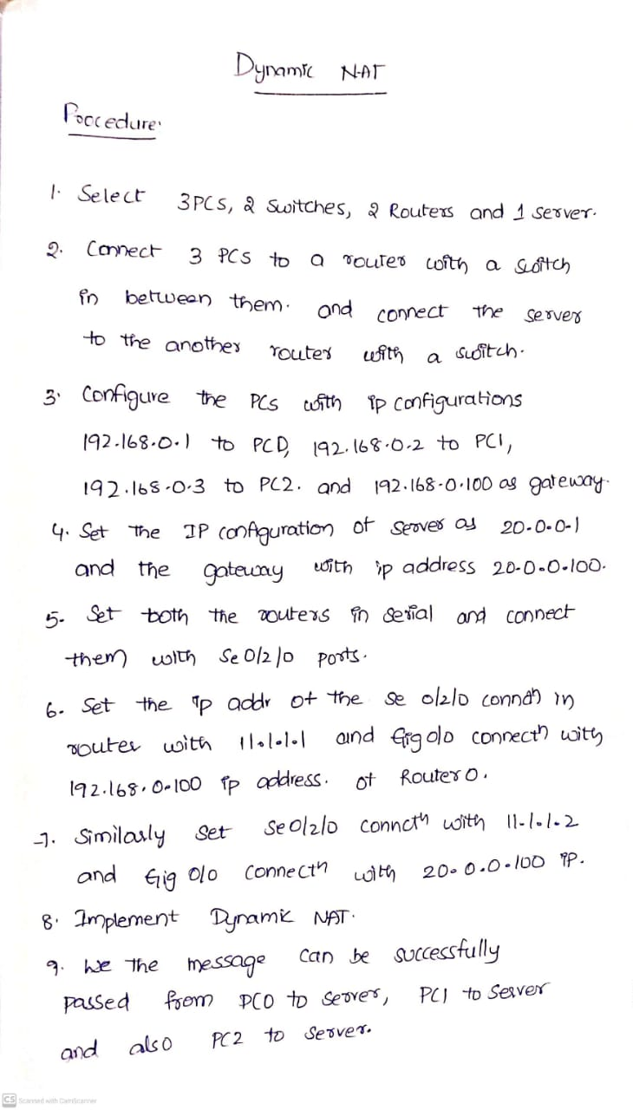

**TOPOLOGY**

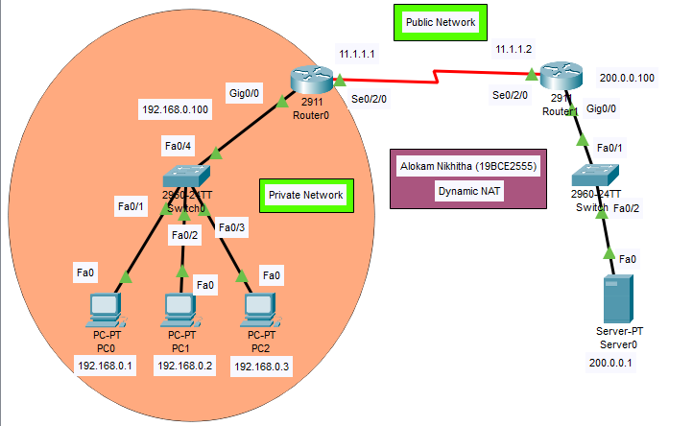

**PC Configuration**

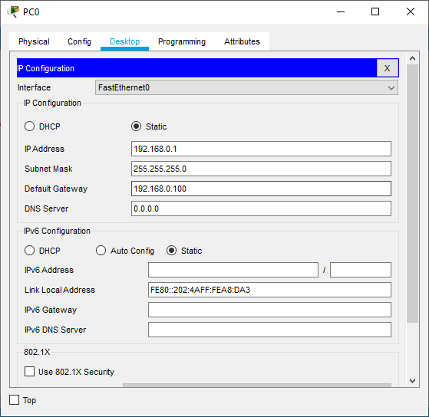

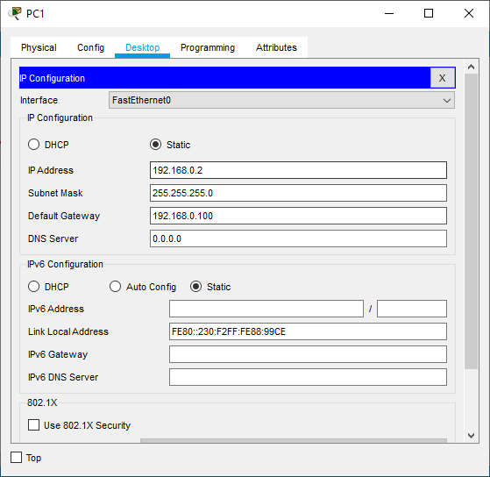

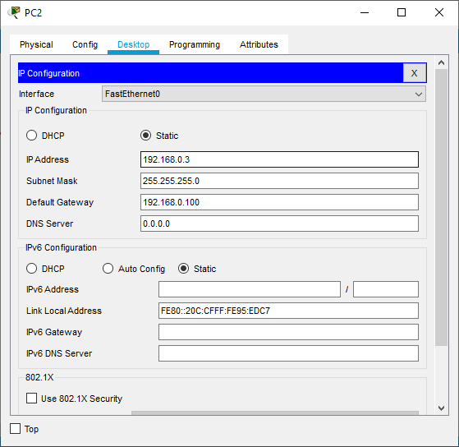

**Server Configuration**

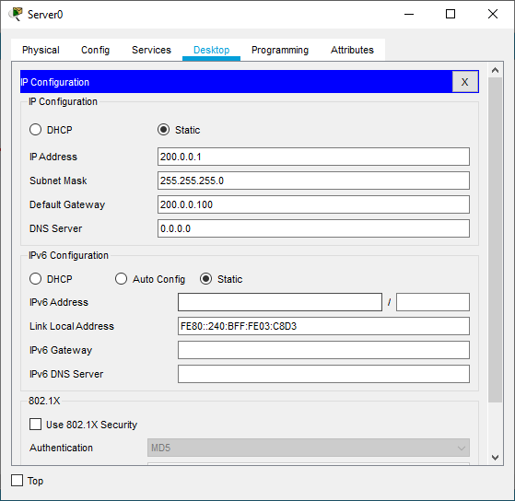

**Router Configuration**

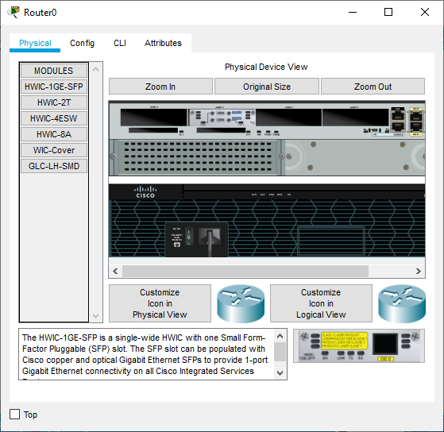

Changing it to serial connection

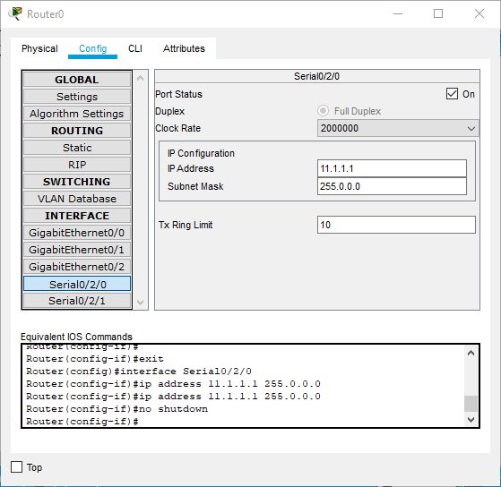

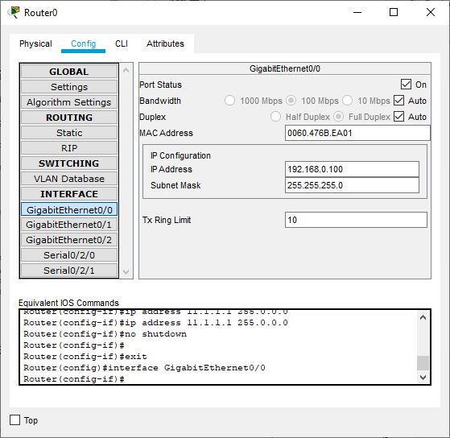

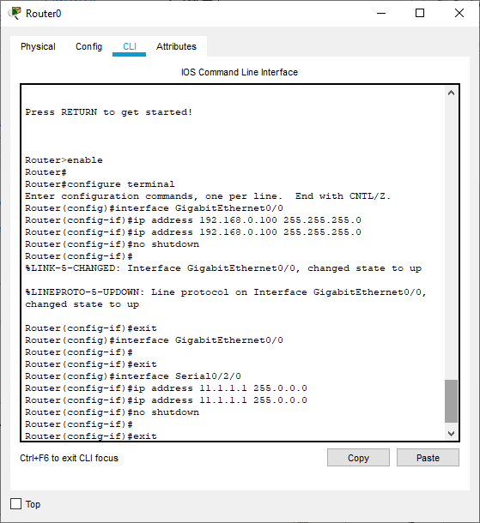

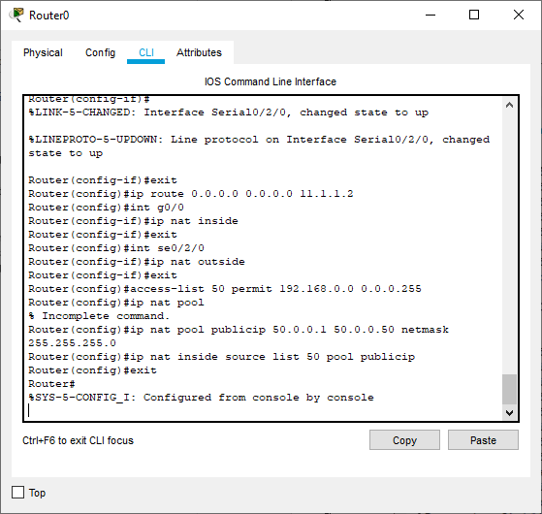

**Router 1**

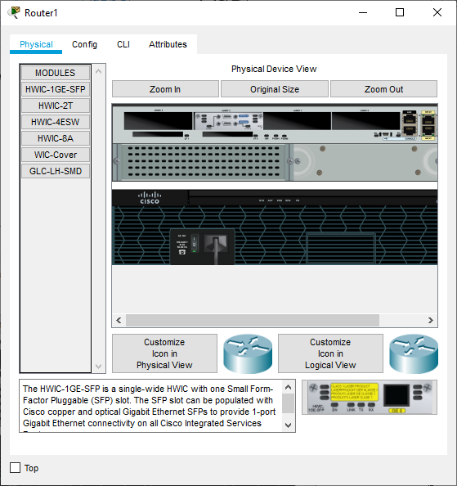

Changing it to serial connection

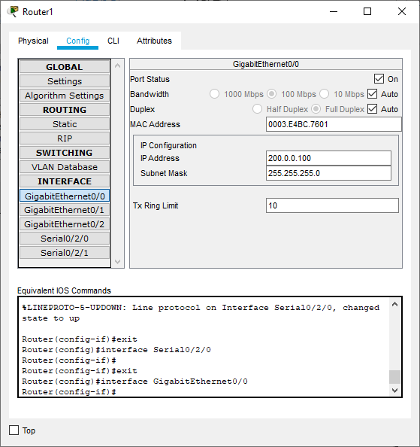

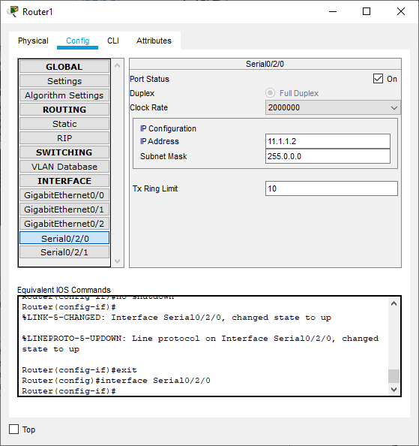

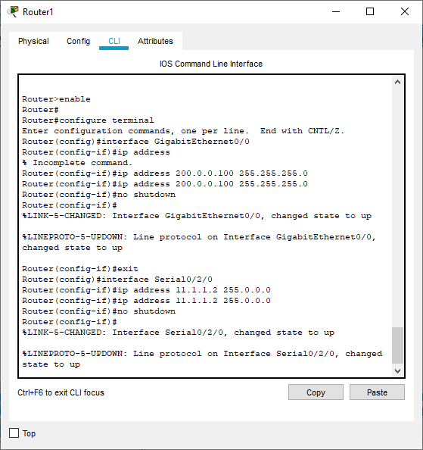

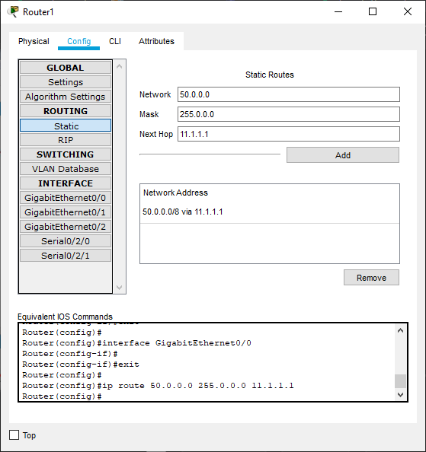

**Results**

**PC0 to server**

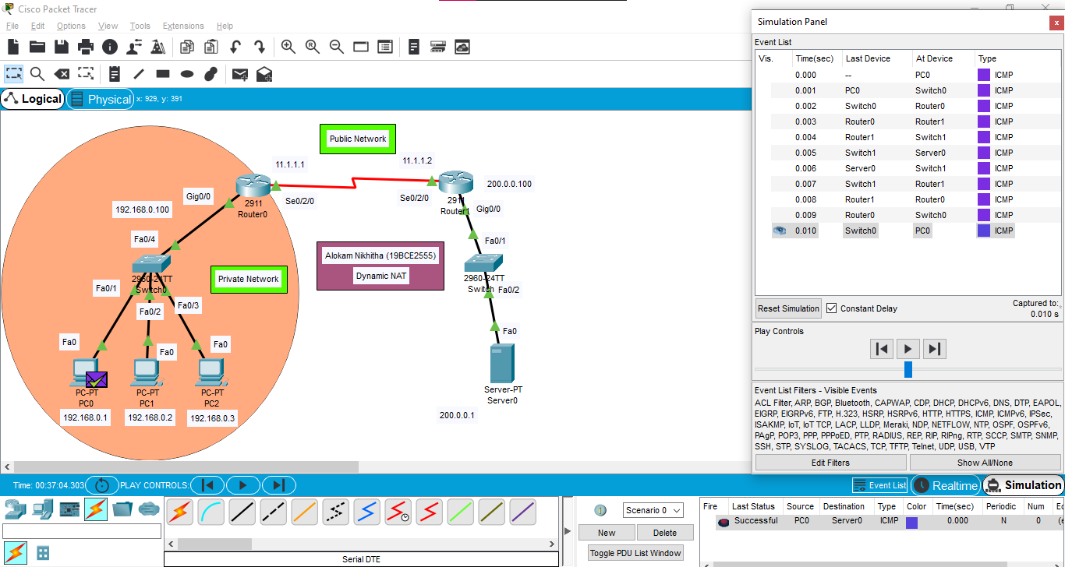

**Event List**

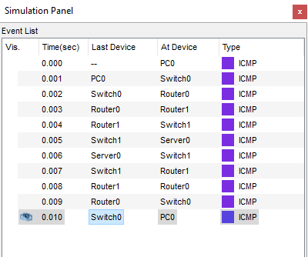

**PDU List Window**

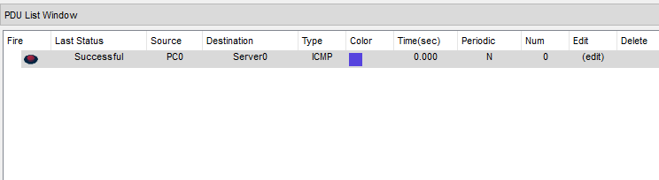

**PC1 to server**

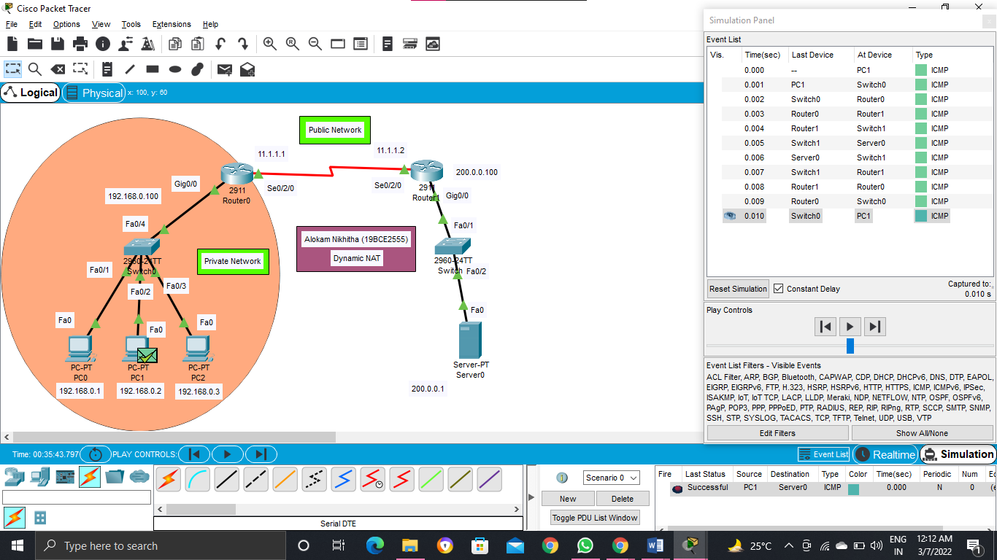

**Event List**

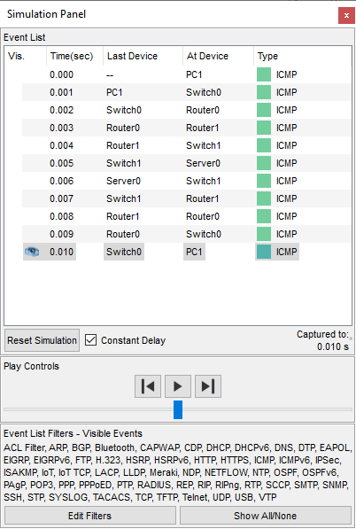

**PDU List window**

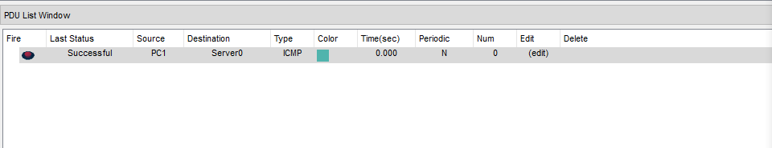

**PC2 to server**

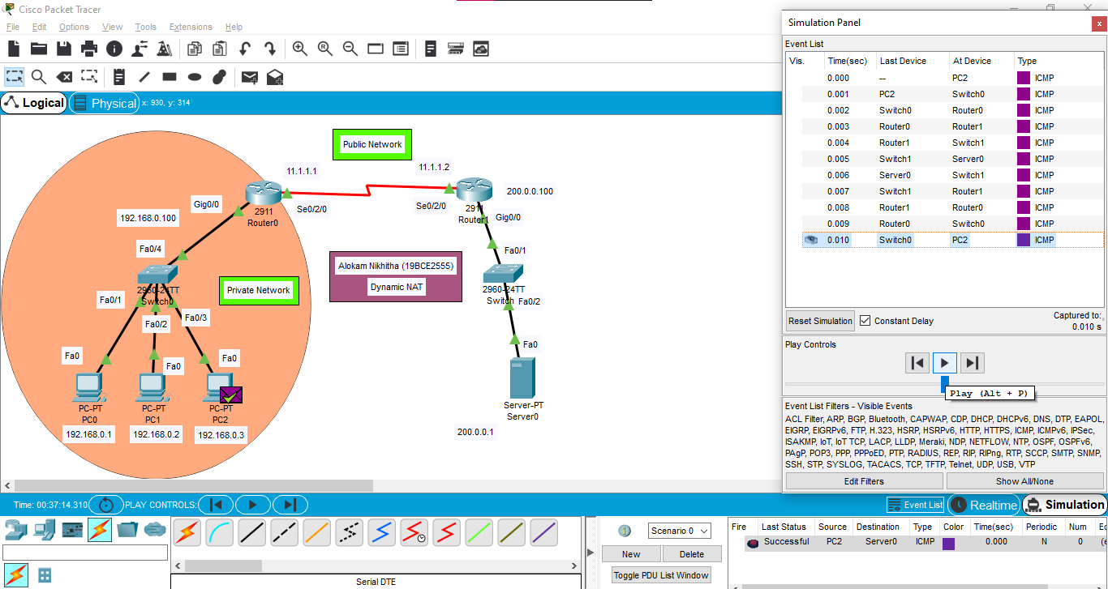

**Event List**

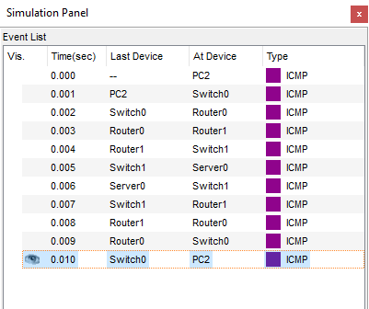

**PDU List Window**

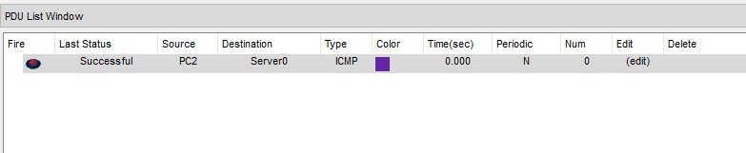

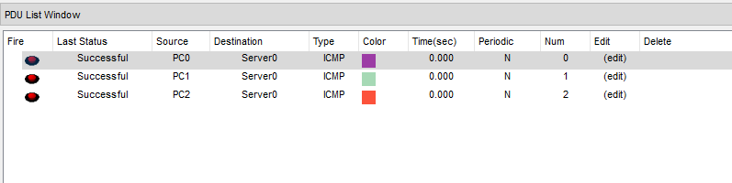

**Conclusion**

**We have successfully implemented Dynamic NAT by connecting the 2 routers in serial connection and the message packet is passed from PC0 to Server0 , PC1 to Server0 and also PC2 to Server0.**